Part 2 - Solution Architecture

A. High Level Architecture Diagram

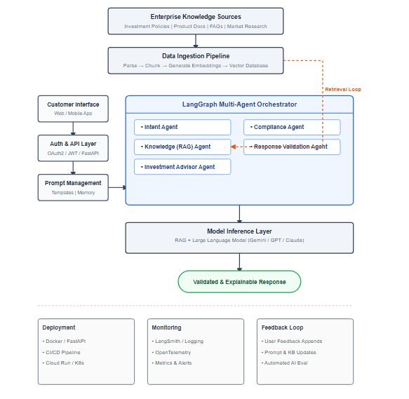

B. Architecture Stages

1. Data Ingestion
Enterprise knowledge sources such as investment policies, regulatory documents, product brochures, FAQs, and market research reports are ingested into the system. The ingestion pipeline extracts text, performs document chunking, generates vector embeddings, and stores them in a vector database to enable Retrieval-Augmented Generation (RAG).
Techniques & Tools
- Python
- LangChain
- PyMuPDF
- Vertex AI Embeddings
- FAISS / Vertex AI Vector Search

2. Prompt Lifecycle Management
Customer queries are processed through a prompt management layer that combines user queries, retrieved knowledge, conversation history, and system instructions to generate optimized prompts. Prompt templates and versioning help ensure consistency and continuous improvement.
Techniques & Tools
- Prompt Templates
- Context Injection
- Prompt Versioning
- Conversation Memory
- LangChain Prompt Templates

3. Multi-Agent Orchestration
LangGraph orchestrates multiple specialized AI agents, each responsible for a specific business capability. This modular approach improves maintainability, scalability, and separation of responsibilities.
Agents
- Intent Agent
- Knowledge (RAG) Agent
- Investment Advisor Agent
- Compliance Agent
- Response Validation Agent
Techniques & Tools
- LangGraph
- LangChain
- Python
Implementation Note: For this assessment, the proof-of-concept implementation includes the Intent Agent, Knowledge Retrieval Agent, and Investment Advisor Agent. The Compliance Agent and Response Validation Agent are part of the proposed production architecture and are identified as future implementation stages.

4. Model Inference
The Knowledge (RAG) Agent retrieves relevant enterprise knowledge from the vector database. The retrieved context is combined with the customer's query and passed to a Large Language Model (LLM) to generate accurate, explainable, and context-aware investment recommendations.
Techniques & Tools
- Retrieval-Augmented Generation (RAG)
- Large Language Model (Gemini / GPT / Claude)
- Semantic Search
- Vertex AI Embeddings

5. Deployment
The solution is designed using a cloud-agnostic architecture. APIs are developed using FastAPI, containerized using Docker, and deployed through CI/CD pipelines. On Google Cloud Platform, services such as Cloud Run and Vertex AI can be used for production deployment.
Techniques & Tools
- FastAPI
- Docker
- GitHub Actions / Cloud Build
- Cloud Run
- Vertex AI
- Kubernetes (Optional)

6. Monitoring & Observability
The platform continuously monitors application health, AI performance, latency, token usage, agent execution, and system errors. End-to-end tracing helps improve prompt quality and troubleshoot production issues.
Techniques & Tools
- LangSmith
- Cloud Logging
- OpenTelemetry
- Cloud Monitoring
- Metrics & Alerts

7. Feedback Loop
Customer feedback and operational metrics are collected to improve prompt quality, update enterprise knowledge, evaluate AI performance, and continuously enhance the solution.
Techniques & Tools
- User Feedback
- Prompt Refinement
- Knowledge Base Updates
- AI Evaluation Metrics
- Continuous Improvement Pipeline

C. Technology Stack
Stage | Technologies
Data Ingestion | Python, LangChain, PyMuPDF, Vertex AI Embeddings, FAISS
Prompt Management | LangChain Prompt Templates, Context Injection, Conversation Memory
Multi-Agent Orchestration | LangGraph, LangChain, Python
Model Inference | RAG, Gemini / GPT / Claude
Deployment | FastAPI, Docker, Cloud Run, Vertex AI, CI/CD
Monitoring | LangSmith, Cloud Logging, OpenTelemetry
Feedback Loop | User Feedback, AI Evaluation, Knowledge Base Updates

D. Justification & Assumptions

Architectural Decisions
Decision | Justification
Agentic AI | Enables specialized agents to handle different business responsibilities, improving modularity and maintainability.
Retrieval-Augmented Generation (RAG) | Grounds responses in trusted enterprise documents, reducing hallucinations and improving explainability.
LangGraph | Provides stateful orchestration for multi-agent workflows.
FastAPI | Lightweight, high-performance REST API framework for AI services.
Cloud-Agnostic Design | Enables deployment across multiple cloud providers while mapping naturally to Google Cloud services.
LangSmith | Provides prompt tracing, agent execution monitoring, and LLM observability.

Assumptions
- Customer authentication is handled by the bank's existing identity provider.
- Enterprise knowledge documents are validated before ingestion.
- The AI assistant provides decision support and does not replace licensed financial advisors.
- Enterprise knowledge sources are periodically updated to ensure response accuracy.

